**B1 Engineering Computation Project**

**Spectral Shaping for Communication Systems**

**Introduction**

With the increasing popularity of ultra-wideband communication, the interference between UWB and other narrowband transmissions has to be avoided. This report demonstrates the procedure of modifying a randomly generated signal sequence to achieve appropriate interference avoidance.

**1.Generating Random Signals**

The simpler code works instead of a “for” loop by generating a matrix of length N and get element values of matrix b in one command. The const\_sum manipulation on a matrix is effective to the manipulation on each element of the matrix.

To make both QPSK and 16-QAM as the const str function input option, use ‘if’ or ‘switch’.

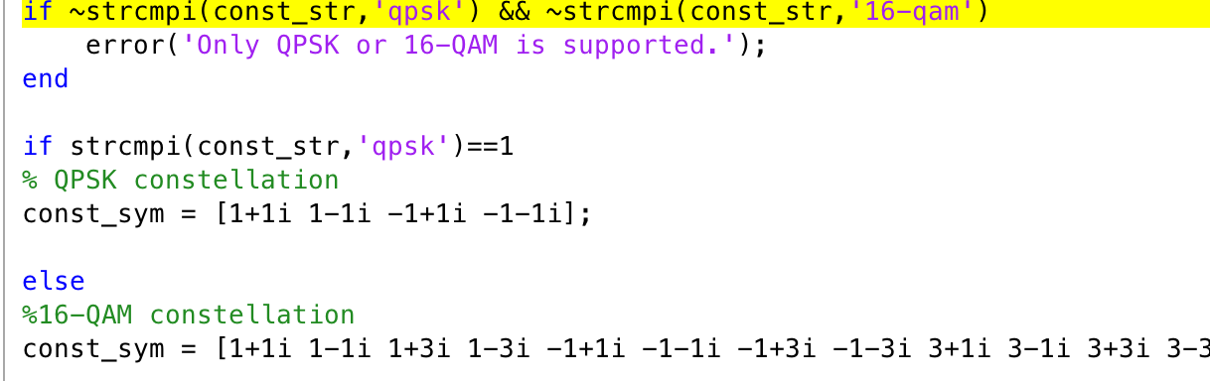

Fig 1. The ‘if’ case

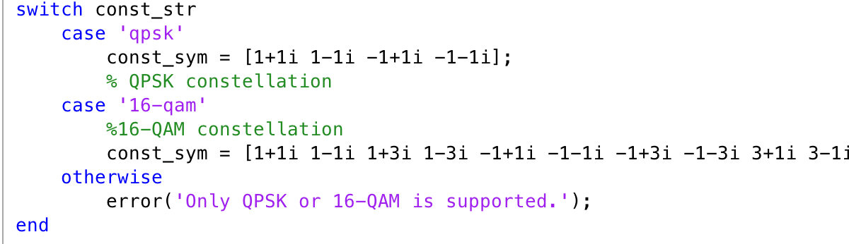

Fig 2. The ‘switch’ case

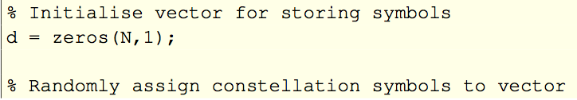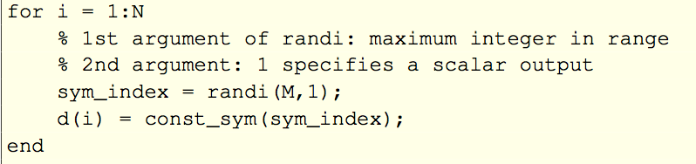

Fig 3. Method1 for assigning signal vector ‘d’

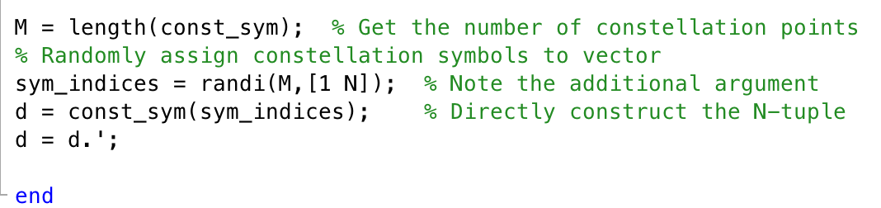

Fig 4. Method2 for assigning signal vector ‘d’

Here ‘d’ is not initialized in Fig 4 because it’s assigned to a [1 N] matrix at one time.

**2. Plotting Generated Signals**

(With vertical axis as imaginary axis and horizontal axis as real axis in the following graphs)

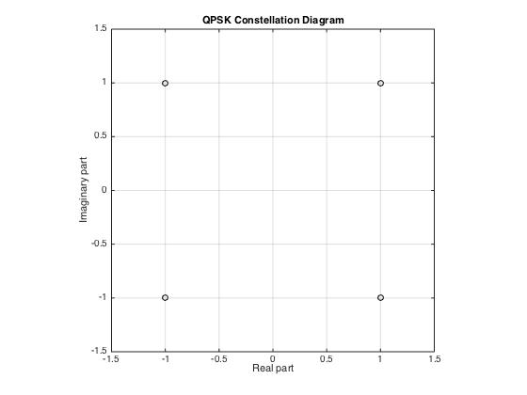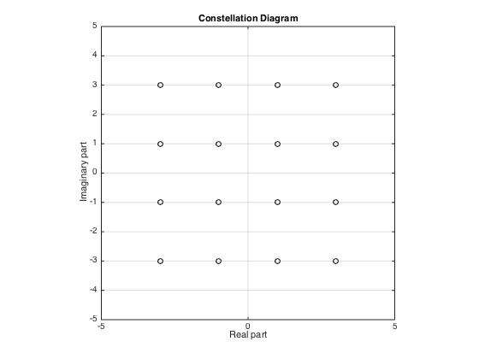

Fig 5. QPSK constellation Fig 6. 16-QAM constellation

**3. Spectral Analysis**

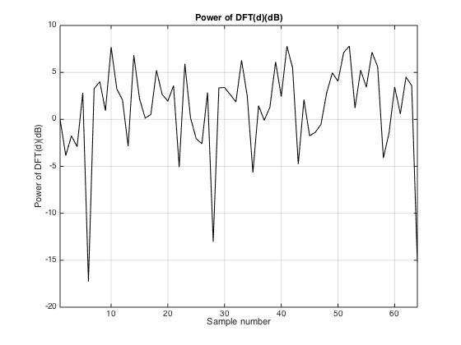

Fig 7. Discrete fourier transform of generated QPSK signal in dB with N = 64

**4. Construct Transfer Function (Window)**

Objective: To create a deep notch in the data signal

The Naive Approach: Simply nulling the required frequency (here is the indices) components of DFT of d and transfer it back to time domain.

|  |  |
| --- | --- |
| Macintosh HD:Users:muchen:Desktop:3rd year:B1-2:report:N=64, indices=[9-12].jpg | Macintosh HD:Users:muchen:Desktop:3rd year:B1-2:report:N=64, indices=[9-18].jpg |
| Fig 8. Constellation diagram of transformed QPSK signal with N = 64 and indices [9:12] | Fig 9. Constellation diagram of transformed QPSK signal with N = 64 and indices [9:18] |

Simply nulling causes both scaling and phase-shift on the original signal. The constellation graph with indices [9:18] if more spread, indicating that with simply nulling, the larger the notch region is relative to the original signal, the more the signal is damaged. Simple notch cause the data in the notched interval lost forever.

**5. Optimization**

Upsampling (interpolating points between original notched time-domain response) 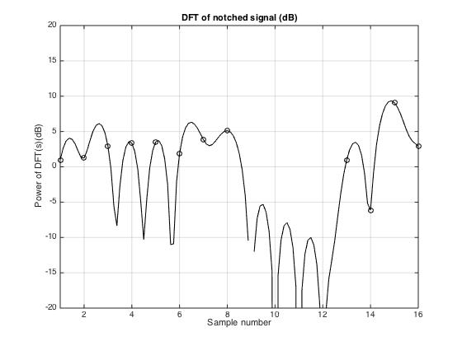

The usage of upsampling approximates the sequence at a higher sampling frequency than the actual frequency, which gives a better approximation of the continuous signal.

Fig 10. Upsampling of DFT of notched signal (dB)

**a. The Eigen-Window Method**

Window coefficients are set to real numbers, causing the phase transfer function to be unity. The phase information of the signal is remained intact. Thus, we are expecting a constellation graph with un-altered phase and a changed magnitude.

According to the definition of DFT operator matrix, W and WI(operator of the notched region) can be constructed. Then get the smallest eigenvalue as well as its corresponding eigenvector, which is the window required.

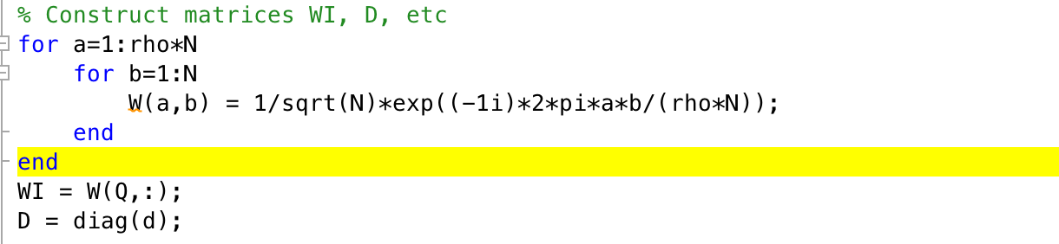

Fig 11. DFT operator construction

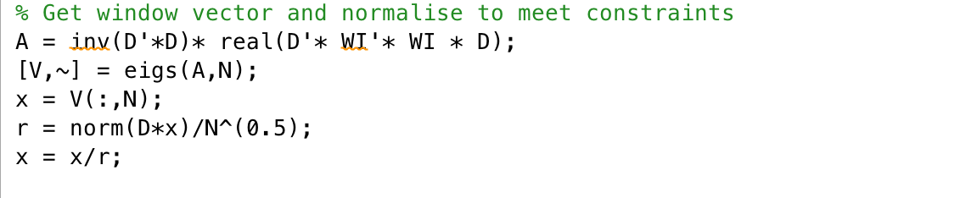

Fig 12. Eigen-window construction

***Results:***

|  |  |
| --- | --- |
| Macintosh HD:Users:muchen:Desktop:eigen_window_DFT.jpg | Macintosh HD:Users:muchen:Desktop:eigen_window_constellation.jpg |
| Fig 13. DFT (dB) of QPSK signal after transformed by eigen-window function  With N=16, rho=8, indices=[9:11] | Fig 14. Constellation graph of QPSK signal after transformed by eigen-window function  With N=16, rho=8, indices=[9:11] |

The transformed signal forms a cross in constellation graph. The constellation points are lined up into two lines perpendicular to each other forming 45-degree angles with the axes, meaning that the only effect window has on the original signal is scaling.

Although it gives a good deep notch with eigen-window method, it’s not suitable here because the elements of the window vector can be either positive or negative numbers, resulting in sign ambiguity, which has to be further decoded with knowledge of the actual window in order to get the initial signal.

**b. The Barrier Method**

Reformulation of the constraints can solve the sign-ambiguity problem. Also, a simple non-negative scaling on all data points will give a spare space in the center of the constellation graph so that the receiver can distinguish between constellation points without knowledge of the window.

The main disadvantage of this formulation is that this is only useful for constant-modulus signals because elements of window can be any number bigger than delta, arising a problem of magnitude ambiguity if there are signals in the same phase but different in modulus.

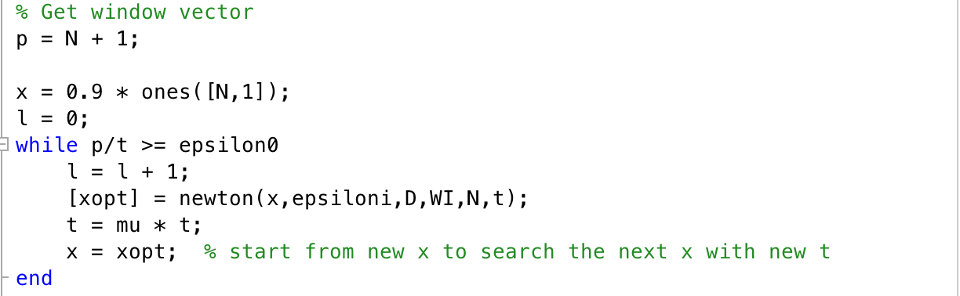

Fig 15. Computing optimal window x with increasing value of t until the approximation is reasonable

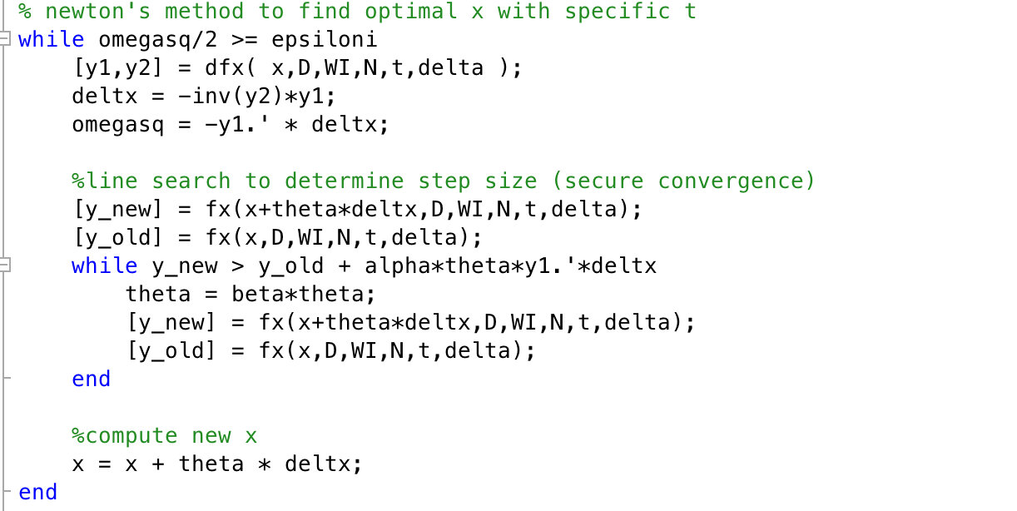

Fig 16. Newton’s method with backtracking line search to find optimal window x with current t

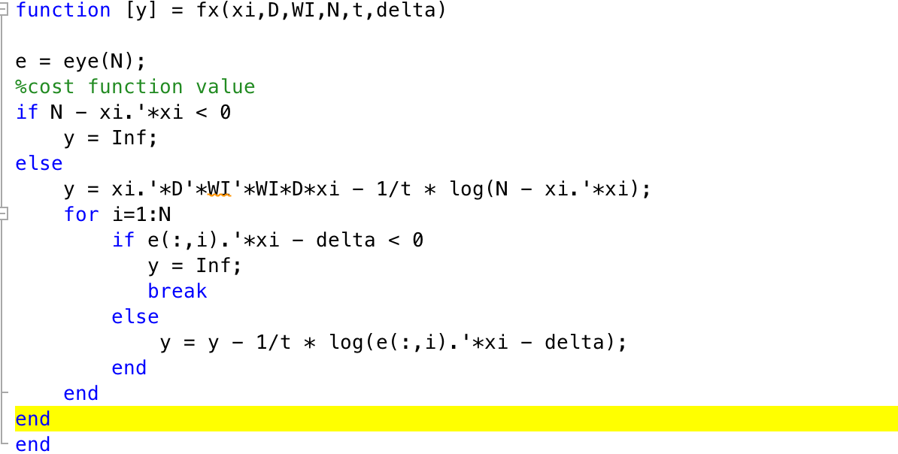

Fig 17. Computation of the approximation of cost function with current t

**Note:**

When computing the approximate cost function (Fig 17), the log function may give complex numbers if the number is negative, causing problem when we compare cost function values in line search. This can be avoided by directly setting the function value to infinity if input value for log is negative.

***Results:***

Use the fast convergence initial conditions for newton’s method [1] , the following graphs are generated:

|  |  |
| --- | --- |
| Macintosh HD:Users:muchen:Desktop:32_8_1.5_0.01_1_freq.jpg | Fig 18. DFT(dB) of QPSK signal after transformed by a window function optimized by barrier method  N=32, rho=8, indices=[9:15], mu=1.5, epsilon0=0.01,epsilon=0.5, initial t=1 |
| Macintosh HD:Users:muchen:Desktop:32_8_1.5_0.01_1_constellation.jpg | Fig 19. Constellation graph of QPSK signal after transformed by a window function optimized by barrier method  N=32, rho=8, indices=[9:15], mu=1.5, epsilon0=0.01,epsilon=0.5, initial t=1 |

*Comments****:***

Barrier method gives a sufficient deep notch in the required interval and also a clear spare space in the center of constellation diagram for receiver to easily read the original signal.

**6. Run-time Analysis**

To analyze the run time and number of iterations of Barrier method with different parameters (epsilon0, epsiloni, initial t, and mu), a separate script is written to plot the above relations.Each graph is plotted after the generation of a new set of signal data, but signal data remains unchanged during the increasing parameter process.

***Results:***

Cputime (left axis)/number of iterations of t (right axis) vs. parameters

|  |  |
| --- | --- |
| Macintosh HD:Users:muchen:Desktop:epsilon0.jpg | Macintosh HD:Users:muchen:Desktop:epsiloni.jpg |
| Fig 20. cputime/iterations vs. epsilon0 | Fig 21. cputime/iterations vs. epsiloni |
| Macintosh HD:Users:muchen:Desktop:mu1_t=1.jpg | Macintosh HD:Users:muchen:Desktop:t6.jpg |
| Fig 22. cputime/iterations vs. mu | Fig 23. cputime/iterations vs. initial t |

Comments:

As expected, the number of iterations of t would decrease with increase of epsilon0 or t or mu since computation continues while p/t < epsilon0 and new t = mu\*t. It would not be affected by epsilon, which is used to define the accuracy of the approximation of optimal window x.

The increase of both epsilon0 and epsiloni cause a decrease in run-time because increase in tolerance means the decrease in accuracy therefore fewer steps is needed. The flat region in epsiloni graph indicates that the tolerance is too large to have any impact on the accuracy. It always meets the condition so it never gets into the accuracy measurement loop.

Cputime interestingly increase in a step shape with increasing initial t. This means that although an increase in t always tends to decrease the iteration number but for each iteration it spends even more time to compute an optimal window. In fact, larger t gives a slower change in gradient and hessian thus gives a slower approach to omega^2 < epsiloni.

**7. 16-QAM Responses and Multiple Notches**

Improvements can be made with Barrier method by simply reformulate the problem. To avoid modulus ambiguity problem raised with 16-QAM signals, restrict the window elements within certain region so that the region displaying small modulus signals does not overlap with that displaying large modulus. To evaluate the relationship between maximum and minimum value of , set . In the 16-QAM case only the 2 types of signals on the diagonal of constellation diagram need to be separated, one with modulus , which would appear in the region of , another group with modulus , which appear in , with r denotes the radius on constellation graph. Therefore, , giving .

To achieve multiple notches, rethink the problem as minimizing the sum of the frequency responses of all notches. Write each notch region as an additional term similar to the previous single-notch problem. Here, take double notches as example.

Problem reformulation:

Minimize

Subject to

and are DFT operators corresponding to two notch regions. Change the corresponding cost function values and its derivatives. Choose and so that all the constraints are meet and they are as far as possible to each other allow deep notches, which in this case, theoretically, is to choose close to 1 (smaller than 1) and take slightly smaller than 3\* . However, since the norm of window is also limited by N, in order to give x enough space to stretch, there may be a trade off between these two constraints, drawing back the value of to small.

Here are some examples:

Code:

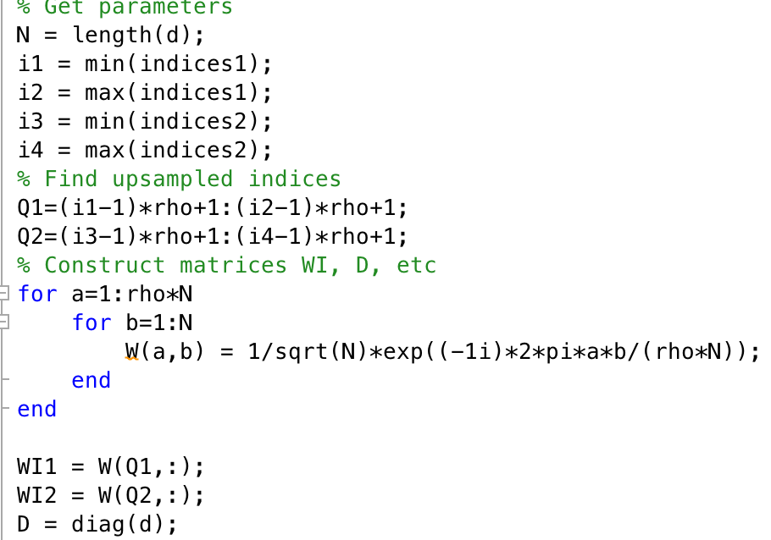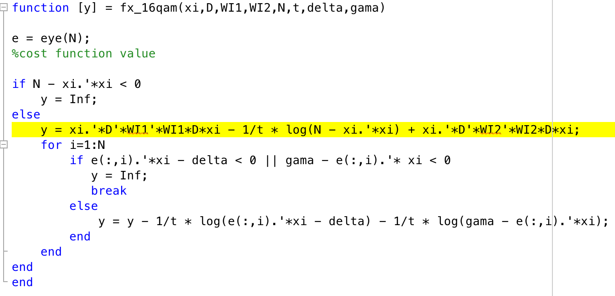

Fig 24. Get WI1 and WI2 Fig 25. Construct cost function

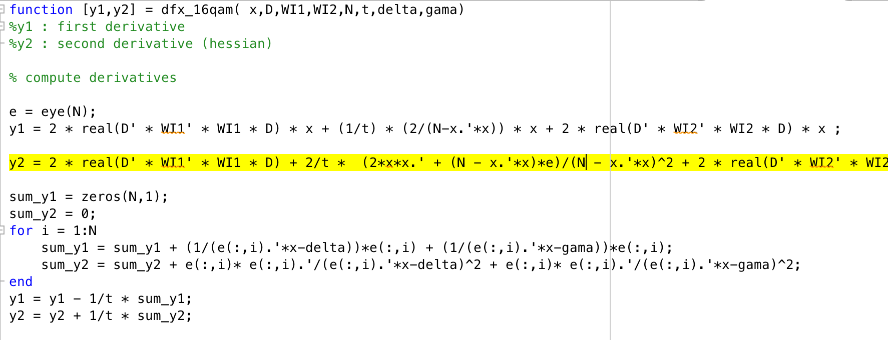

Fig 26. Construct gradient and hessian

***Results:***

|  |  |
| --- | --- |
| Macintosh HD:Users:muchen:Desktop:128_gama1.7_1.jpg | Macintosh HD:Users:muchen:Desktop:128_gama1.7_2.jpg |
| Fig 27. Frequency response with N=128 | Fig 28. Constellation graph with N=128 |
| Macintosh HD:Users:muchen:Desktop:final512_2.jpg | Macintosh HD:Users:muchen:Desktop:final512_1.jpg |
| Fig 29. Frequency response with N=512 | Fig 30. Constellation graph with N=512 |

Various values of and are tried with ranges from 0.5 to 2.3 and from 0.2 to 0.8. Most of the pairs give good notch with N=512, sometimes with N=256, rarely with N=128. It’s more likely to give good results with in the range of 0.35 to 0.6.

We can see the discontinuity formed on the diagonals (Fig 28), indicating the success of separating signals by there modulus. The receiver can therefore easily distinguish between signals with different modulus by simply detecting its transformed modulus.

**Conclusion**

In this project, two types of random signals are firstly generated, with QPSK of constant modulus and 16-QAM of non-constant modulus. Then, ways of analyzing and plotting the signals in both time domain and frequency domain are explored. The problem is approached initially with simple nulling, which causes large distortion of signal phase and amplitude. Large amount of information is lost during the process. By applying a proper window vector, adding constraints requiring its elements to be real or positive, information can be remained intact. Both Eigen-window method (using Lagrange multiplier) and Barrier method (using indicator function and its approximation) can transfer constrained optimization problems into unconstrained problems. Eigen-window method successfully preserved signal’s phase property, however, gives an ambiguity in sign. Barrier method gives both a deep notch in the desired interval and a good preservation of signal phase and magnitude information. It is shown that in most cases, the computation of barrier method can be done in 2 seconds for 64 QPSK signals. Other improvements can be made on Barrier method to achieve non-constant modulus signal capability and multiple notches by reformulating the optimization objective.

**Reference**

[1] J.P.Coon, “Narrowband interference avoidance for ultra-wideband single-carrier block transmissions with frequency-domain equalization”, IEEE wireless communications, 2008